The Effect of Perceived Ease of Use and Perceived Usefulness on E-Wallet Continuance Intention Among Generation Z: The Mediating Role of Satisfaction

Marcel Listanto¹, Ika Pratiwi Simbolon^{2*}
Management Study Program, Universitas Bunda Mulia, Indonesia
Corresponding Author: Ika Pratiwi : ikapratiwi.simbolon@gmail.com

A R T I C L E I N F O | A B S T R A C T
Keywords: Perceived Ease of Use, Perceived Usefulness, Satisfaction, Continuance Intention.  Received: 20, May  Revised: 15 June  Accepted: 10 July  ©2026 Listanto, Simbolon (s): This is an open-access article distributed under the terms of the Creative Commons Atribusi 4.0 Internasional.   | Digital payment services are experiencing high growth, resulting in an increase of e-wallets adoption among gen-z. This study analizes the effect of perceived ease of use and perceived usefulness on continuance intention, with satisfaction as a mediating variable. Data are obtained through an online survey of 150 respondents in Greater Jakarta and processed by using PLS-SEM. Based on the results, perceived ease of use has significant effect on satisfaction. Perceived usefulness has significant effect on satisfaction and continuance intention. Satisfaction also has significant effect on continuance intention and serves as a full mediator between perceived ease of use and continuance intention.

INTRODUCTION
Digital technology development has transformed various aspects of daily life especially for payment system. The growth of digital banking, electronic payments, and QRIS transactions in Indonesia reflects the increasing adoption of digital financial services (Bank Indonesia, 2024). One of the most widely used digital payment instruments is the electronic wallet (e-wallet), which enables users to conduct transactions conveniently through mobile devices. The increasing integration of digital services into everyday activities has strengthened the role of e-wallets as an essential component of the digital economy.
The development of e-wallet services has also intensified competition among service providers. Beyond facilitating cashless transactions, providers continuously compete through promotional programs, service innovation, transaction efficiency, and ecosystem integration. Research on digital payment adoption in Indonesia indicates that users are increasingly attracted to payment solutions that offer convenience, flexibility, and practical benefits in their daily activities (Ferdinan et al., 2024). Similarly, Santoso et al. (2024) found that users tend to prefer digital wallet services that provide ease of use, functionality, and a seamless transaction experience. These findings suggest that perceived benefits and user experience play important roles in influencing users’ decisions to adopt and continue using digital payment services.
Among different demographic groups, gen-z represents one of the most active users of digital technologies and financial applications (IPSOS, 2026; Kompas, 2026; Kumparan, 2026). Growing up in a highly digitalized environment, this generation is familiar with mobile-based services and frequently utilizes digital payment platforms for various transactions. Consequently, Generation Z provides a relevant context for examining the determinants of continued use of e-wallet services.
Previous studies on digital financial services have found the importance of perceived usefulness and perceived ease of use in shaping users’ behavioral intentions and post-adoption behavior (Geasela et al., 2022; Sinurat & Sugiyanto, 2022; Suryatenggara & Dahlan, 2022). Users continue using a digital service when provides meaningful benefits and can be used with minimal effort. However, continuance behavior is not determined solely by users’ perceptions of a technology.
Previous studies have found inconsistent results for determinants of continuance intention. These mixed findings indicate the need for further investigation, particularly in the context of e-wallet usage among gen-z. Based on these considerations, this study aims to examine the effect of perceived ease of use and perceived usefulness on continuance intention with satisfaction as a mediating variable among gen-z e-wallet users in Greater Jakarta.

LITERATURE REVIEW
Perceived usefulness is described as a condition where users believe that technology could provides meaningful benefits in completing tasks. Applications are used by users when improving transaction efficiency, convenience, and overall effectiveness, especially for e-wallet services. Previous studies have consistently reported significant effect between perceived usefulness and continuance intention in various digital technology contexts (Jo & Bang, 2023; Mishra et al., 2023; Savitha et al., 2022).
Perceived ease of use reflects the condition when users believe that technology can be used with minimal effort. A system that is easy to learn, understand, and operate may encourage users to continue using the technology. In e-wallet services, a simple interface and convenient transaction process can enhance users’ willingness to maintain usage. Prior studies have shown that perceived ease of use contributes positively to continuance intention (Kusairi et al., 2025; Mishra et al., 2023; Savitha et al., 2022).
Users tend to feel more satisfied when a technology provides substantial benefits and supports their daily activities effectively. In the e-wallet context, perceived usefulness may enhance users’ evaluation of their overall experience because the service helps them conduct transactions more efficiently. Previous studies have demonstrated that perceived usefulness significantly influences user satisfaction in the adoption of digital technology (Kusairi et al., 2025; Prawira et al., 2024; Seridaran et al., 2024).
Perceived ease of use may improve users’ experiences by reducing the effort required to operate a system. When users can easily understand and utilize an e-wallet application, they are more likely to develop favorable evaluations of the service. Previous research has reported significant effect between perceived ease of use and satisfaction in various digital service settings (Kusairi et al., 2025; Mishra et al., 2023; Prawira et al., 2024).
Satisfaction reflects users’ overall evaluation after experiencing a service. Users who are satisfied with a technology are more likely to continue using it in the future. Within the e-wallet context, positive experiences associated with convenience, reliability, and usefulness may strengthen users’ intention to maintain usage. Previous studies have confirmed that satisfaction is a significant determinant of continuance intention in digital payment and information system environments (Prawira et al., 2024; Savitha et al., 2022; Seridaran et al., 2024).
Users’ perceptions regarding the usefulness and ease of use of a technology may influence their decision to continue using technology through the formation of satisfaction. When users perceive an e-wallet as beneficial and easy to use, they satisfy and tend to continue using the technolgy. Previous studies have found that satisfaction mediates the relationship between technology-related perceptions and continuance intention (Mishra et al., 2023; Prawira et al., 2024; Savitha et al., 2022).
Research Framework
This research proposes that perceived usefulness and perceived ease of use influence continuance intention both directly and indirectly through satisfaction. Users who perceive an e-wallet as useful and easy to use are expected to experience higher satisfaction, which subsequently encourages their intention to continue using the service.
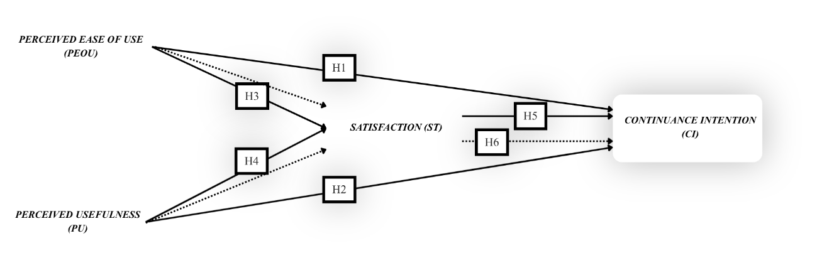

Figure 1. Conceptual Framework

METHODOLOGY
This research is quantitative research because it focuses on collecting numerical data (numbers) and statistical analysis. An explanatory research design is also adopted because the study aimed to investigate causal relationships among the proposed variables and test the formulated hypotheses empirically.
The population of this study consisted of gen-z individuals who use e-wallet applications in the Greater Jakarta area. A purposive sampling approach is applied to select respondents who met the research criteria. The criteria included individuals belonging to gen-z, residing in Greater Jakarta, and having prior experience using e-wallet services. A total of 150 respondents were collected and analyzed.
Data are analyzed by using Partial Least Squares Structural Equation Modeling. The analysis consisted of two stages: evaluation of the measurement model and evaluation of the structural model. In addition, mediation analysis was performed to evaluate the role of satisfaction in mediating the relationships between perceived usefulness and continuance intention, as well as between perceived ease of use and continuance intention. The significance of indirect effects was assessed using the bootstrapping approach, following the guidelines for mediation testing in PLS-SEM (Hair et al., 2022).

RESEARCH RESULT
Measurement Model Evaluation
All indicators achieved outer loading values above the recommended threshold of 0.70, while all AVE values > 0.50, indicating satisfactory convergent validity. Furthermore, the results showed that all constructs achieved values > 0.70, indicating adequate internal consistency and construct reliability.

Table 1. Reliability and Validity Assessment
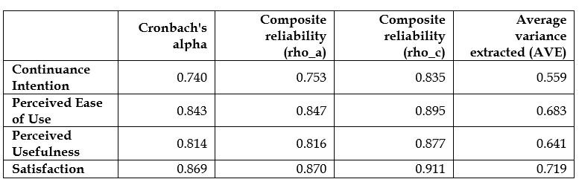
Discriminant validity was evaluated using the Heterotrait-Monotrait Ratio (HTMT). All HTMT values were below the recommended threshold of 0.90, confirming that each construct was empirically distinct from the others.
Table 2. Discriminant Validity
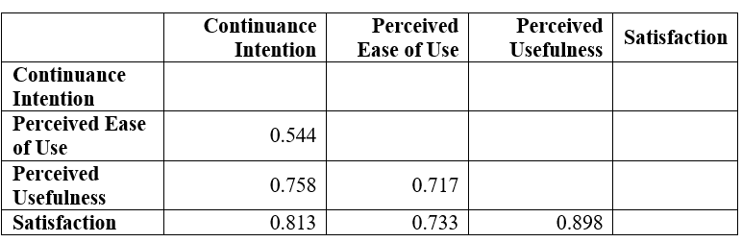
Structural Model Evaluation
R² value for satisfaction indicated the extent to which research model is explained 62.4% of user satisfaction. Meanwhile, R² value for continuance intention reflected the research model is explained 47.1% of continuance intention.
Table 3. Coefficient of Determination (R²)
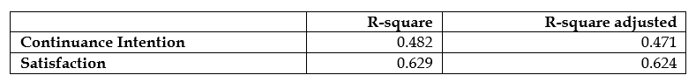
Hypothesis Testing
The results revealed that perceived usefulness has significant effect on continuance intention. In contrast, perceived ease of use has no significant effect on continuance intention. Furthermore, both perceived usefulness and perceived ease of use have significant effect on satisfaction. Satisfaction also has significant effect on continuance intention.
Table 4. Direct Effects
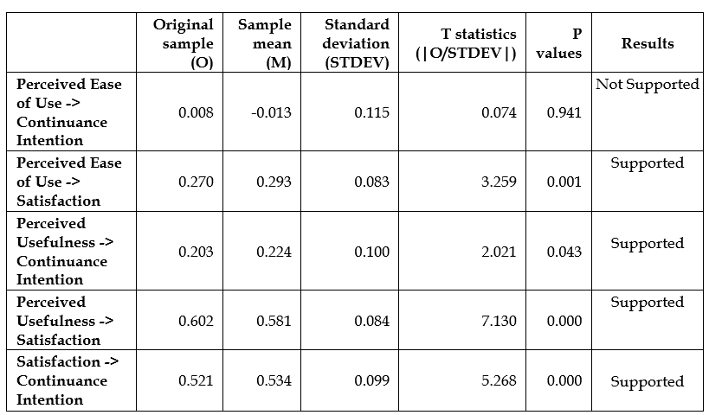
Mediation Analysis
The results demonstrated that satisfaction significantly mediated the relationship between perceived ease of use and continuance intention, indicating full mediation. Furthermore, satisfaction significantly mediated the relationship between perceived usefulness and continuance intention.
Table 5. Specific Indirect Effects
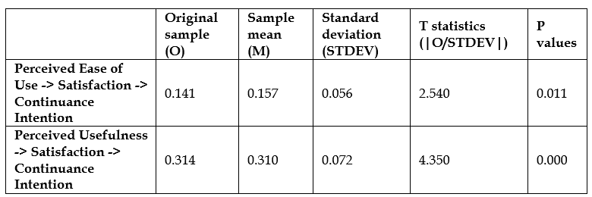

DISCUSSION
Based on the results, users continue using an e-wallet when they perceive tangible benefits from the application, such as transaction efficiency, convenience, and support for daily financial activities. The finding is consistent with the Technology Acceptance Model (TAM), which posits that perceived usefulness is a key determinant of technology acceptance and continued use. This result also supports previous studies conducted by Jo & Bang (2023), Mishra et al. (2023), and Savitha et al. (2022), which found that perceived usefulness has significant effect on continuance intention in digital technology contexts.

In contrast, ease of use alone is insufficient to encourage continued usage of e-wallet services among gen-z users. As digital natives, gen-z is generally familiar with mobile applications and digital technologies. Users tend to place greater emphasis on the practical benefits and value the application offers. This finding indicates that perceived usefulness may be more influential in explaining continuance intention within the e-wallet context.

The study also found that both perceived usefulness and perceived ease of use have significant effect on satisfaction. Respondents experience greater satisfaction when e-wallet services offer meaningful benefits and enhance transaction efficiency. At the same time, an application that is easy to understand and operate contributes positively to user experience and satisfaction. These findings are consistent with previous studies by Prawira et al. (2024), Kusairi et al. (2025), Mishra et al. (2023), which reported that usefulness and ease of use are important antecedents of user satisfaction in digital service environments.

Furthermore, satisfied users continue using e-wallet services in the future. Positive experiences with convenience, functionality, and overall service quality encourage users to develop a stronger commitment to continued use. This result supports the expectation-confirmation perspective and aligns with prior studies conducted by Savitha et al. (2022), Prawira et al. (2024), and Seridaran et al. (2024), which identified satisfaction as a factor that affect continuance intention.
Ease of use does not directly influence continued usage; instead, it first enhances user satisfaction, which subsequently drives continuance intention. In addition, satisfaction partially mediated the relationship between perceived usefulness and continuance intention. This finding suggests that perceived usefulness affects continuance intention both directly and indirectly through satisfaction. Therefore, satisfaction serves as an important mechanism by which users’ perceptions of e-wallet services translate into continued usage.

CONCLUSIONS
Perceived usefulness has significant effect on continuance intention. Users continue using e-wallet services when they perceive substantial benefits from the application rather than merely finding it easy to use.
The mediation analysis shows that satisfaction fully mediates the relationship between perceived ease of use and continuance intention and partially mediates the relationship between perceived usefulness and continuance intention. These findings emphasise the critical role of satisfaction in translating users’ perceptions of e-wallet services into long-term usage intentions.

RECOMMENDATIONS
Based on the findings, e-wallet providers should focus on enhancing usefulness of services by expanding digital service integration, improving transaction efficiency, and developing features that support users’ daily financial activities. Such efforts may strengthen users’ perceptions of value and encourage continued usage.
E-wallet providers should also maintain high levels of user satisfaction through reliable system performance, secure transactions, responsive customer support, and continuous service innovation. Satisfaction has been identified as a key determinant of Continuance Intention, which means improving overall user experience remains essential for sustaining user retention.
For future research, the other variables such as trust, perceived security, promotional benefits, social influence, or habit may be incorporated to provide a broader understanding of continuance intention in digital payment services. Future studies may also examine different demographic groups or geographical regions to get better results.

ACKNOWLEDGMENT
The author would like to express sincere gratitude to all respondents who participated in this study and provided valuable information for this research. The author also extends appreciation to the academic supervisors, lecturers, and colleagues for their guidance, support, and constructive feedback, which contributed to the completion of this research. Finally, the author is grateful to all parties who directly or indirectly assisted in the completion of this study.

REFERENCES

Bank Indonesia. (2024). Tinjauan Kebijakan Moneter Juni 2024. https://www.bi.go.id/id/publikasi/laporan/Pages/TKM-Juni-2024.aspx

Chen, X., Jiang, L., Zhou, Z., & Li, D. (2025). Impact of perceived ease of use and perceived usefulness of humanoid robots on students’ intention to use. Acta Psychologica, 258. https://doi.org/10.1016/j.actpsy.2025.105217

Ferdinan, G., Christy Arviana Montana, A., Valentina Tamrin, C., & Gede Wisnu Satria Chandra Putra, I. (2024). Analisis faktor-faktor yang mempengaruhi minat penggunaan QRIS sebagai sistem pembayaran pada bisnis retail Superindo Analysis Of Factors Affecting The Internet In Using QRIS As Payment System In Superindo Retail Business. Digismantech, Vol. 4(No. 2). https://doi.org/10.30813/digismantech.v4i2.7605

Geasela, Y. M., Hartono, H., Sesilia, M., Winarto, H., & Pratiwi, H. (2022). Analisis penerimaan aplikasi aset digital menggunakan Technology Acceptance Model (TAM). JBASE - Journal of Business and Audit Information Systems, 5(2). https://doi.org/10.30813/jbase.v5i2.3778

Geasela, Y. M., Hartono, H., Sutanto, D., Julian, K., & Setiawan, J. (2022). Analisis sistem informasi web penjualan pada PT TETA dengan pendekatan model TAM. JBASE - Journal of Business and Audit Information Systems, 5(1). https://doi.org/10.30813/jbase.v5i1.3462

Hair, J. F., Hult, G. T. M., Ringle, C. M., Sarstedt, M., Danks, N. P., & Ray, S. (2022). Classroom Companion: Business Partial Least Squares Structural Equation Modeling (PLS-SEM) Using R. https://doi.org/https://doi.org/10.1007/978-3-030-80519-7

Jo, H., & Bang, Y. (2023). Understanding continuance intention of enterprise resource planning (ERP): TOE, TAM, and IS success model. Heliyon, 9(10). https://doi.org/10.1016/j.heliyon.2023.e21019

Kompas. (2026, February). Gen Z Jadi Akselerator Pertumbuhan E-wallet. https://money.kompas.com/read/2026/02/23/224700426/gen-z-jadi-akselerator-pertumbuhan-e-wallet

Kumparan. (2026, February 24). Survei Ipsos: E-wallet Paling Banyak Digunakan Buat Belanja Online-Transfer | kumparan.com. https://kumparan.com/kumparanbisnis/survei-ipsos-e-wallet-paling-banyak-digunakan-buat-belanja-online-transfer-26tPy6lkq2B/2

Kusairi, K., Sukmawati, A., A.S, N., & Rahman, M. S. (2025). Predicting M-banking adoption: the moderating role of age in technology acceptance. Cogent Business and Management, 12(1). https://doi.org/10.1080/23311975.2025.2547964

Mishra, A., Shukla, A., Rana, N. P., Currie, W. L., & Dwivedi, Y. K. (2023). Re-examining post-acceptance model of information systems continuance: A revised theoretical model using MASEM approach. International Journal of Information Management, 68. https://doi.org/10.1016/j.ijinfomgt.2022.102571

Populix. (2025). Penggunaan QRIS Jadi Pilihan Digital Favorit. https://info.populix.co/articles/penggunaan-qris-jadi-pilihan-digital-favorit/

Prawira, F. R., Prakoso, N. T., Handayani, P. W., & Harahap, N. C. (2024). The influence of information security factors on the continuance use of electronic wallet. Procedia Computer Science, 234, 1467–1475. https://doi.org/10.1016/j.procs.2024.03.147

Santoso, I. C., Stefanus Kembau, A., & Julius Sutrisno. (2024). "Mengapa Pengguna Memilih Dompet Digital GoPay? Studi. Digismantech, 4(1), p-ISSN. https://doi.org/10.30813/digismantech.v4i1.5937.g2956

Savitha, B., Hawaldar, I. T., & Kumar K, N. (2022). Continuance intentions to use FinTech peer-to-peer payments apps in India. Heliyon, 8(11). https://doi.org/10.1016/j.heliyon.2022.e11654

Seridaran, S., Sithamparam, A. G., Falahat, M., & Ekmekcioğlu, Ö. (2024). Determinants of continuance usage intentions: the mediating role of satisfaction and trust in branded mobile applications among Malaysians. Cogent Business and Management, 11(1). https://doi.org/10.1080/23311975.2024.2402082

Sinurat, E. M., & Sugiyanto, L. B. (2022). Pengaruh Perceived Usefulness, Perceived Ease of Use dan Promosi Penjualan melalui Mediasi Attitude Toward Using dan Perceived Security terhadap Behavioral Intention to Use (Studi Empiris: Pengguna Mobile Wallet di Jakarta). Business Management Journal, 18(1), 17. https://doi.org/10.30813/bmj.v18i1.2820

Suryatenggara, G. M., & Dahlan, K. S. S. (2022). The Effect of Perceived Usefulness, Perceived Ease of Use and Perceived Price on Customer Loyalty in Gojek Through Customer Satisfaction (Study on Gojek Apps Users in Jabodetabek). Journal of Business & Applied Management, 15(2), 171. https://doi.org/10.30813/jbam.v15i2.3866

